**FOR IMMEDIATE RELEASE**

**Pasadena Symphony Association Pasadena Symphony & POPS** Contact: Marisa McCarthy

[mmccarthy@PasadenaSymphony-Pops.org](mailto:mmccarthy@PasadenaSymphony-Pops.org) (626) 793-7172 ext. 13

August 18, 2022

For artist images and bios, visit: <https://pasadenasymphony-pops.org/broadway-on-film-press-release/>

# PASADENA POPS SEASON FINALE BRINGS TWO TONY WINNERS FOR THE BEST OF HIT SHOWS THAT TRAVELED FROM BROADWAY TO HOLLYWOOD

***Pasadena, CA*** *–* Principal Pops Conductor **Michael Feinstein** and the **Pasadena POPS** close the **2022 Rusnak Summer Concert Series** at the **Los Angeles County Arboretum** on **Saturday, September 10** with **Broadway on Film**, honoring the best of hit shows that traveled from 42nd St. to Hollywood. The multiple Grammy® and Emmy-nominated entertainer has put together a program spanning the Broadway canon from *Funny Girl, Showboat* and *The Music Man* to *Chicago* and *The Wiz*, with “Home,” “Don’t Rain on My Parade,” “Old Devil Moon” and so much more. In quintessential Feinstein fashion, he has unearthed charts that haven’t been heard by a live audience in many years, including a few premieres.

“Here in Southern California we have incredible access to arrangements that were created for Hollywood films (with very creative writing for orchestra), so we are able to interpret these Broadway standards using a larger palette, giving them a sort of majesty that one cannot experience on Broadway.” *– Michael Feinstein.*

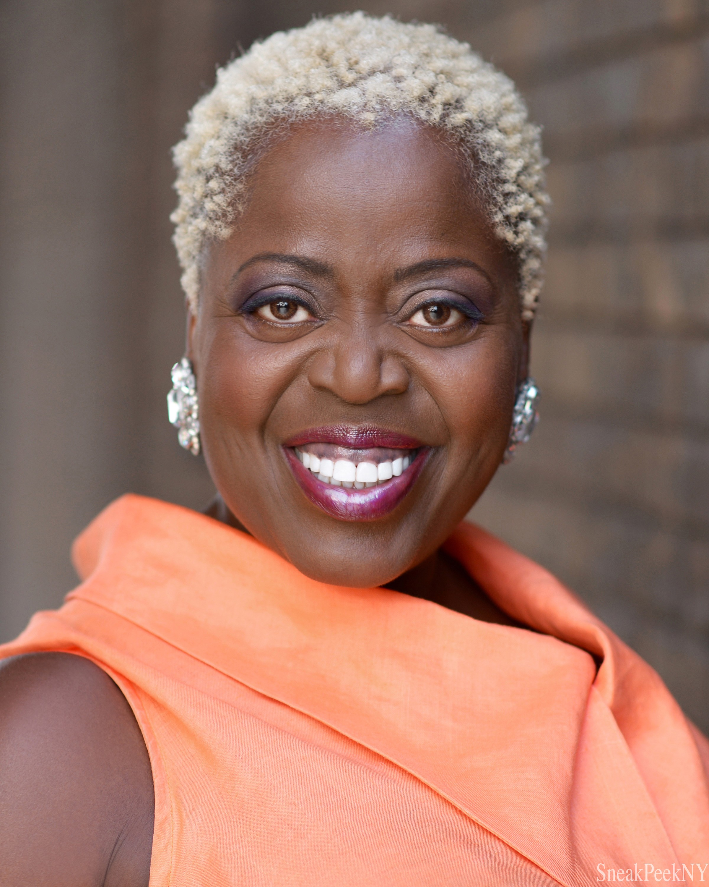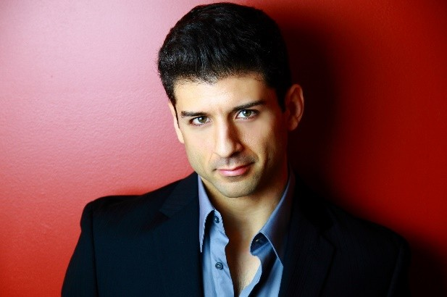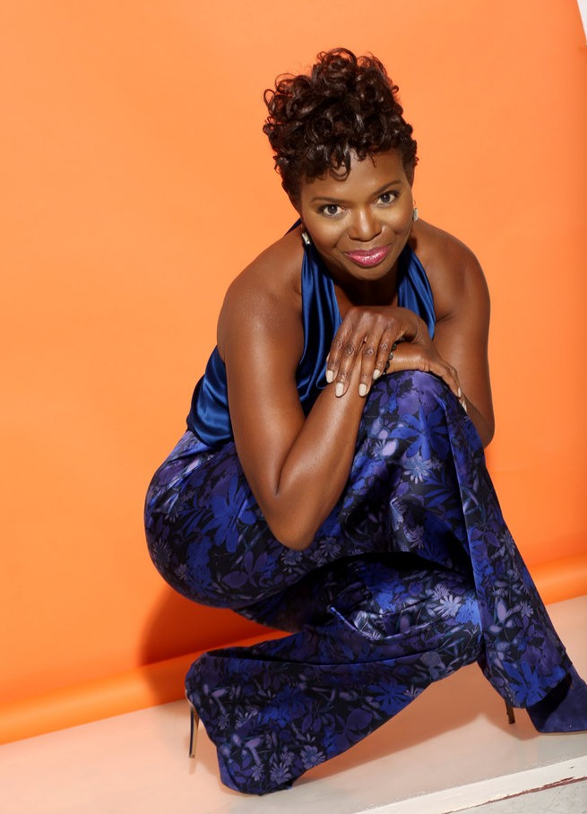

Three Broadway superstars will bring down the house for an evening full of top-notch singing and dancing at this spectacular season finale. The stage will light up with the powerhouse vocals of Tony® award-winners **Lillias White (Best Actress for Cy Coleman’s *The Life*)** and the “magnetic” (*New York Times*) **LaChanze (Best Actress, *The Color Purple*).** Plus, song and dance man, and **Tony*®*- nominee Tony Yazbeck (*On the Town*)** will channel Fred Astaire with his fancy footwork to bring these blockbusters to life.

All concerts are held at the Los Angeles County Arboretum and Botanic Gardens. Grounds open for picnicking and dining at 5:30pm and performances begin at 7:30pm. Don’t miss the best outdoor dinner party in town with spacious circular table seating with fine linens, or lawn seating for those who want to bring a blanket – each option carries on the tradition of picnic-dining with your family and friends listening to the San Gabriel Valley’s premier orchestra! Among many venue amenities, concert goers can enjoy pre- ordered gourmet box dinners for on-site pickup just steps from their table or a variety of food truck options.

The Arboretum is located at 301 North Baldwin Ave., Arcadia, CA. Subscribers may purchase pre-paid onsite parking at the Arboretum, and all concertgoers can purchase guaranteed and convenient parking at Santa Anita Park, with non-stop shuttle service to the Arboretum’s main entrance.

Tickets start at $25, and are available by calling the box office at (626) 793-7172, online at [PasadenaSymphony-Pops.org](https://pasadenasymphony-pops.org/) or at the Arboretum on concert days.

# IF YOU GO:

* **What:** The Pasadena POPS presents Broadway on Film **Michael Feinstein,** *Principal Pops Conductor* **LaChanze,** *soloist*

**Lillias White**, *soloist*

**Tony Yazbeck,** *soloist*

* **When:** Saturday, September 10, 2022 at 7:30pm. Gates open at 5:30pm.
* **Where:** The LA County Arboretum | 301 N Baldwin Ave., Arcadia, CA 91007
* **Cost:** Tickets start at $25.00
* **Dining:** Gates open at 5:30pm for picnicking. Guests are welcome to bring their own food and drink or visit one of the many onsite food vendors.
* **Parking:** Subscribers have the opportunity to purchase onsite Arboretum parking. Single ticket holders may purchase guaranteed and convenient parking at Santa Anita Park, located just across Baldwin Ave., with non-stop shuttle service to the Arboretum’s main entrance for $10. Available for pre-purchase or **cash only on-site.**

# ABOUT THE ARTISTS

## Michael Feinstein Principal Pops Conductor

In addition to his recognition as one of the leading musical entertainers and piano virtuosi of recent decades, Michael Feinstein’s work as an educator, archivist, interpreter, and Ambassador of the Great American Songbook have established the popular and honored musician as a pre-eminent force in contemporary music. His dazzling career as a top-selling and critically acclaimed recording artist and a star performer on Broadway, and the world’s great concert stages has earned him five GRAMMY® Award nominations, two Emmy nominations of his PBS-TV specials and acclaim for is NPR series. His live

concerts have spanned the globe including such iconic venues such as The White House, Buckingham Palace, Hollywood Bowl, Carnegie Hall, and the Sydney Opera House.

As one of cabaret’s most famous champions has forged a collaboration with New York’s renowned room and storied venues, Café Carlyle.

In 2022, Feinstein released to rave reviews, *Gershwin Country*, an album of standards in duet with some of the biggest names in Country Music from Dolly Parton and Alison Krauss to Brad Paisley and Amy Grant. *Gershwin Country* charted at Number 7 on the Billboard’s Country Charts.

In 2007, as an extension of his work as a legendary performer and passionate guardian of his nation’s greatest musical traditions, Mr. Feinstein founded the Great American Songbook Foundation. The Foundation works to preserve and elevate America’s rich musical legacy by curating physical artifacts of its creators and performers; offering programs for the public and research opportunities for scholars, historians, and performers; and providing educational opportunities for student musicians, including the annual high school Songbook Academy®. For over a decade, Michael served as a Founding Member on the Library of Congress’ National Recording Preservation Board; an organization dedicated to ensuring the survival, conservation and increased public availability of America’s sound recording heritage.

Feinstein earned his fifth Grammy Award nomination in 2009 for *The Sinatra Project*, his CD celebrating the music of “Ol’ Blue Eyes.” *The Sinatra Project, Volume II: The Good Life* was released in 2011. He released the CDs *The Power Of Two* – collaborating with “Glee” and “30 Rock” star Cheyenne Jackson – and *Cheek To Cheek*, recorded with Broadway legend Barbara Cook. For Feinstein’s CD *We Dreamed These Days*, he co-wrote the title song with Dr. Maya Angelou.

His Emmy Award-nominated TV special *Michael Feinstein – The Sinatra Legacy*, which was taped live at the Palladium in Carmel, IN, aired across the country in 2011. The PBS series “Michael Feinstein’s American Songbook,” the recipient of the ASCAP Deems-Taylor Television Broadcast Award, was broadcast for three seasons and is available on DVD. His most recent primetime PBS-TV Special, “New Year’s Eve at The Rainbow Room” *–* written and directed by “Desperate Housewives” creator Marc Cherry *–* aired in 2014. For his nationally syndicated public radio program “Song Travels,” Michael interviewed and performed alongside of music luminaries such as Bette Midler, Neil Sedaka, Liza Minnelli, Rickie Lee Jones, David Hyde Pierce and more.

Feinstein was named Principal Pops Conductor for the Pasadena Symphony in 2012 and made his conducting debut in June 2013 to celebrated critical acclaim. Under Feinstein’s leadership, the Pasadena Pops has quickly become a premier orchestral presenter of the Great American Songbook with definitive performances of rare orchestrations and classic arrangements. He launched an additional Pops series at the Kravis Center for the Performing Arts in Palm Beach, Florida in 2014.

Michael’s book *The Gershwins and Me* – the *Los Angeles Times* best-seller from Simon & Schuster – features a new CD of Gershwin standards performed with Cyrus Chestnut at the piano.

Feinstein serves as Artistic Director of the Center for the Performing Arts, a $170 million, three-theatre venue in Carmel, Indiana, which opened in January 2011. The theater is home to diverse live programming and a museum for his rare memorabilia and manuscripts. Since 1999, he has served as

Artistic Director for Carnegie Hall’s “Standard Time with Michael Feinstein” in conjunction with ASCAP. In 2010 he became the director of the Jazz and Popular Song Series at New York’s Jazz at Lincoln Center.

Feinstein’s at the Nikko, Michael’s nightclub at San Francisco’s Nikko Hotel, has presented the top talents of pop and jazz since 2013. He debuted at Feinstein’s/54 Below, his new club in New York, late in 2015. His first venue in New York, Feinstein’s at the Regency, featured major entertainers such as Rosemary Clooney, Glen Campbell, Barbara Cook, Diahann Carroll, Jane Krakowski, Lea Michele, Cyndi Lauper, Jason Mraz, and Alan Cumming from 1999 to 2012. Most recently, Feinstein opened his first Los Angeles location, Feinstein’s at Vitello’s in June of 2019.

He has designed a new piano for Steinway called “The First Ladies,” inspired by the White House piano and signed by several former First Ladies. It was first played to commemorate the Ronald Regan centennial on February 6, 2011.

In 2013 Michael released *Change Of Heart: The Songs of Andre Previn* in collaboration with four time Oscar and eleven time Grammy Award-winning composer-conductor-pianist Andre Previn. The album celebrates Previn’s pop songs and motion picture classics. Earlier album highlights include *Hopeless Romantics*, a songbook of classics by Michael’s late friend Harry Warren, recording with legendary jazz pianist George Shearing. His album with songwriting icon Jimmy Webb, *Only One Life – The Songs of Jimmy Webb*, was named one of “10 Best CDs of the Year” by *USA Today*.

Feinstein received his fourth Grammy nomination for *Michael Feinstein with the Israel Philharmonic Orchestra*, his first recording with a symphony orchestra. The year before, Rhino/Elektra Music released *The Michael Feinstein Anthology*, a two-disc compilation spanning 1987 to 1996 and featuring old favorites and previously unreleased tracks.

Michael was born and raised in Columbus, Ohio, where he started playing piano by ear as a 5-year-old. After graduating from high school, he moved to Los Angeles when he was 20. The widow of legendary concert pianist-actor Oscar Levant introduced him to Ira Gershwin in July 1977. Feinstein became Gershwin’s assistant for six years, which earned him access to numerous unpublished Gershwin songs, many of which he has since performed and recorded.

Gershwin’s influence provided a solid base upon which Feinstein evolved into a captivating performer, composer, and arranger of his own original music. He also has become an unparalleled interpreter of music legends such as Irving Berlin, Jerome Kern, Johnny Mercer, Duke Ellington, and Harry Warren.

Feinstein has received three honorary doctorates.

Through his live performances, recordings, film and television appearances, and his songwriting (in collaboration with Alan and Marilyn Bergman, Lindy Robbins, Bob Merrill, and Marshall Barer), Feinstein is an all-star force in American music.

For more information, please visit [**www.MichaelFeinstein.com**](http://www.michaelfeinstein.com/). **LaChanze**

## Soloist

Without question, LaChanze is one of the brightest stars and voices to ever hit Broadway. She currently stars as Diva Donna in the high voltage production *Summer The Donna Summer Musical* at the Lunt- Fontanne Theatre. Of her performance, *The Hollywood Reporter* says, “LaChanze brings class”

with *Vulture* proclaiming, her voice “might in fact be able to bring plaster down from the ceiling.” Her volcanic performance landed her nominations for the 2018 Tony Award nomination for Leading Actress in a Musical, 2018 Drama Desk Award Outstanding Actress in a Musical and 2018 Drama League Award for Distinguished Performance Award. In addition to her consistently brilliant stage work, LaChanze continues to make her mark in film and television and concert stages across the U.S.

In television and film, she stars in writer/director Marishka Phillips’ suspense filled film *Melinda*. She also appeared in the award-winning film *The Help* where she landed a SAG Award for Outstanding Performance by a Cast in a Motion Picture. Other screen projects include *Side Effects, Heartbreak Hotel, For Love or Money, Leap of Faith and My New Gun*. On television, she appeared in the award-winning HBO special *The Night of, Person of Interest, Law & Order: SVU, One Life to Live, Lucy, Sex and the City, The Cosby Show,* among others.

LaChanze is an accomplished and sought-after concert performer who has the honor of appearing in the PBS special and cast album *Handel’s Messiah Rocks: A Joyful Noise*. This appearance resulted in her earning the covenant Emmy Award for her performance Her electric and highly praised tour *Feeling Good* continues to raise roofs and touch the heart of audiences’ worldwide. With her tour and album of the same name, LaChanze’s *Feeling Good* mixes the perfect blend of emotional intensity with sultry vocals leaving onlookers feeling every pain, joy and excitement she felt during those moments of her life.

With a long list of accolades to her name, she is among today’s most highly regarded performers. Hailed by the *New York Times* as “magnetic,” LaChanze theatre credits are vast, including *The Color*

*Purple* (2006 Tony Award for Best Performance by a Leading Lady in Musical), *Once on this Island* (nominations, Tony, Drama Desk and Outer Critics Circle), *If/Then, Ragtime,*

*Company,* and *Uptown It’s Hot.* Some of her Off-Broadway credits include *The Bubbly Black Girl Sheds her Chameleon Skin* (Drama Desk nomination), *Dessa Rose* (Obie Award), *Inked Baby, Spunk* and From the *Mississippi Delta*.

Not one to rest on her laurels, LaChanze is the author of *Little Diva* (with illustrations by Brian Pinkey). Released in May 2010, *Little Diva* offers a realistic and endearing view of a little girl’s dream of taking to the stage like her mother, a Broadway star.

## Lillias White Soloist

Described by *The New York Times* as a “one-of-a-kind performer who combines the sass of a classic blues mama with the skill of a Broadway star,” Lillias White is world-renowned for her “glorious” voice and “slightly superhuman” ability to communicate the heart of a song (*The New York Times*).

Her performance in Cy Coleman’s Broadway musical, *The Life,* won her the Tony® Award for Best Featured Actress in a Musical. She was nominated for a second Tony® Award for her brilliant work

in *Fela!* Additional Broadway credits include: *Barnum, Dreamgirls, Cats, Carrie, Once on This Island, How To Succeed in Business Without Really Trying,* and *Chicago.* Other Off-Broadway and Regional Credits

include The Public Theater’s *Romance in Hard Times*, for which she won the Obie® Award, *Ma Rainey’s Black Bottom* (directed by Phylicia Rashad), for which she won the NAACP Award, and the Carnegie Hall Concert version of *South Pacific,* starring Reba McEntire, which was also broadcast on PBS’ *Great Performances.*

In addition to receiving Broadway acclaim, Lillias is internationally-recognized for her TV and film work.

Lillias received the Daytime Emmy® Award for her role as Lillian Edwards for Outstanding Performer in a Children’s Series on *Sesame Street* in 1992, and is beloved by audiences around the world for voicing the lead muse Calliope in Disney’s animated feature *Hercules.* Film credits include *Pieces of April* (starring Katie Holmes) and *How the Grinch Stole Christmas* (starring Jim Carrey)*.* Recent TV credits include the Baz Luhrmann-directed Netflix series *The Get Down*, as well as *Russian Doll* and *Search Party*. She has appeared in cabarets and concert halls around the world, including The Kennedy Center, Carnegie Hall and the Sydney Opera House.

She can be heard on several Broadway cast albums, in addition to her acclaimed *From Brooklyn to Broadway. Get Yourself Some Happy!* is Lillias’ debut solo studio album, released in July 2021.

## Tony Yazbeck Soloist

Born in Riverside, CA, Tony Yazbeck moved to Bethlehem, PA at age 4, when he first saw Fred Astaire dance on a black and white TV screen. Tony danced around the living room, pretending he was Mr. Astaire, so his mom and dad put him in dance class right away.

At age 11, he auditioned to be a replacement “Newsboy” in the Tyne Daly *Gypsy*, directed by Arthur Laurents. For the next two years, his mother drove him two hours in each direction, six days a week, from Bethlehem, PA to the stage door of The St. James Theater.

A year after closing *Gypsy*, at age 14, his family moved to The Poconos, where Tony worked on a farm to make extra money. He moved to Orlando at age 16, where he studied at Dr. Phillips Performing Arts High School. He attended Point Park University in Pittsburgh for two years, working at Disney his first summer and in the ensemble at the PCLO his second. He then transferred to Cincinnati Conservatory of Music for his third year of college. In April of 2000, he was cast in the national tour of *Annie Get Your Gun*.

In 2001, Tony made the dream of being a true New Yorker a reality, when the tour closed and he officially moved to the city. Various Broadway/Off-Broadway/Encores!/Regional Theatre/Television/National Tours/London Concerts have subsequently ensued, culminating most recently in a Tony Award Nomination for Best Leading Actor in a Musical for his turn as “Gabey” in the Broadway revival of *On The Town*.

Tony is exceedingly passionate about directing, choreographing and writing in new and creative ways for stage and TV. The first incarnation of these efforts is his solo show *The Floor Above Me*. Tony is also a devoted teacher, most frequently at the National Young Arts Foundation, where he is a master teacher, panelist and assistant director to the legendary Bill T. Jones.

The most important achievement of his life-to-date, however, happened in October 2014, when, right after opening in the aforementioned revival of *On The Town*, Tony married the love of his life, actress, dancer, singer, choreographer and budding director Katie Huff.

# ABOUT THE PASADENA SYMPHONY ASSOCIATION

Formed in 1928, the Pasadena Symphony and POPS is an ensemble of Hollywood’s most talented, sought after musicians. With extensive credits in the film, television, recording and orchestral industry, the artists of Pasadena Symphony and POPS are the most heard in the world.

The Pasadena Symphony and POPS performs in two of the most extraordinary venues in the United States: Ambassador Auditorium, known as the *Carnegie Hall of the West,* and the luxuriant Los Angeles Arboretum & Botanic Garden. The multi-platinum-selling, two-time Emmy and five-time Grammy Award-nominated entertainer dubbed “The Ambassador of the Great American Songbook,” Michael Feinstein, leads the POPS as Principal POPS Conductor, succeeding Marvin Hamlisch.

A hallmark of its robust education programs, the Pasadena Symphony Association has served the youth of the region for over five decades through the Pasadena Youth Symphony Orchestras (PYSO) comprised of seven performing ensembles, with over 700 gifted 4th-12th grade students from 85 schools all over Southern California. The PYSO Symphony has performed at venues across the globe as well as on the television show *GLEE*.

The PSA provides people from all walks of life with powerful access points to the world of symphonic music.

-end-